Crop Recommendation and Soil Profile Analysis for Sustainable Farming: Classification, Clustering and Robustness Evaluation
[Khaled Alfehaid], [Yousef Alsehibani ], [Khalid Alrasheed ], [Abdulmajeed Aljasir]
CS316: Introduction to AI and Data Science, Term 261 [Prince Sultan University]
Abstract— Choosing crops that don't match the local soil

conditions means relying heavily on fertilisers and irrigation. This increases costs and negatively affects the soil and water. We present a data driven approach to a crop recommendation problem with the Crop Recommendation dataset (2200 samples, 22 different crops, 7 features). Seven different classifiers were tested. A stratified 80/20 train-test split was applied with 5-fold cross-validation. The soft voting ensemble reached an accuracy of 99.55% on the test set and 99.5% macro-F1 score. The ensemble also achieved a 100% accuracy on the top 3 recommendation. Globally the most important features influencing crops are relative humidity, annual rain and potassium, however nitrogen is a key factor when recommending crops such as cotton. An unsupervised clustering analysis was performed to show K Means can identify broad clusters related to agriculture (0.44 ARI score; k=10). However, the Gaussian Mixture Model with 22 components accurately reflects the true crop clusters (0.89 ARI score). Adding 20% artificial sensor noise reduced the ensemble model accuracy to 90.7% showing the high scores are due to the upper limit of the accuracy on the clean data.
Keywords— crop recommendation, Sustainable Farming, random forest, ensemble learning, K-Means, Gaussian mixture model, robustness.

INTRODUCTION
Often farmers select their crops based on what is popular in the region or what is trending. If the crop does not match the conditions, then the farmer will use large amounts of synthetic fertilisers which increases costs and causes land degradation. Selecting the right crops to plant will help achieve Sustainable Development Goals SDG 2 and SDG 12 (Responsible Consumption and Production) [1].

This study uses the free Crop Recommendation dataset [2] to identify: (1) what the best crops to plant based on soil conditions (N/P/K, Ph, Temperature, Humidity and Annual Rainfall). (2) Any inherent clusters within the environmental conditions. (3) What features are most important in influencing crop choice. Overall contributions include:

An ensemble with a variety of models combined using soft voting. This was tested using stratified cross-validation, a holdout test set and top 3 recommendation metric to make it applicable to a recommendation tool.

A breakdown of the feature importance to identify if rainfall or nitrogen is more important for different crops.

Comparison of clustering algorithms including K Means, Ward Hierarchical and Gaussian Mixture Models to identify how well they perform compared to true crop clusters.
Testing the robustness of the data by adding noise to see how well the model performs.

As there is no information about yield or fertiliser usage, we will look at the accuracy of the predictions to give us a baseline for how well the inputs can be reduced. Code and setup can be found at [GitHub repository URL]

RELATED WORK
Machine learning plays an essential role in precision agriculture with applications in soil management, irrigation, and crop planning [3]. Literature reviewing crop yield and recommendation models have shown weather and soil conditions are often used as inputs with random forest, neural networks, and linear models being widely used [4][5]. Random forest [6] is great to use as they can model non-linear boundaries, and the feature of importance can be easily interpreted. We compare 7 different classifiers and analyze how well they generalize and their sensitivity to noise.

METHODOLOGY
- Dataset Description and Analysis

The Crop Recommendation dataset [2] has 2200 samples containing 8 features (N/P/K, Temperature (C), Relative Humidity (%), Ph, Annual Rainfall (mm) and Crop (22 different crops, 100 samples per crop). Due to a balanced distribution of classes, we can use overall accuracy as our main metric. Table I shows summary statistics for each feature.
TABLE I
Summary Statistics of the Features

Feature Mean Std Min Max

N | 50.55 | 36.92 | 0.00 | 140.00
P | 53.36 | 32.99 | 5.00 | 145.00
K | 48.15 | 50.65 | 5.00 | 205.00
Temperature (°C) | 25.62 | 5.06 | 8.83 | 43.68
Humidity (%) | 71.48 | 22.26 | 14.26 | 99.98
pH | 6.47 | 0.77 | 3.50 | 9.94
Rainfall (mm) 103.46 54.96 20.21 298.56

We can confirm that the dataset has no missing or duplicated values using pandas. The nutrients are integers whilst the weather and Ph are floating. Figure 1 shows the distribution of data. Potassium and Annual Rainfall are positively skewed; Humidity is negatively skewed where values are above 60%, and Ph is normally distributed around 6.5.

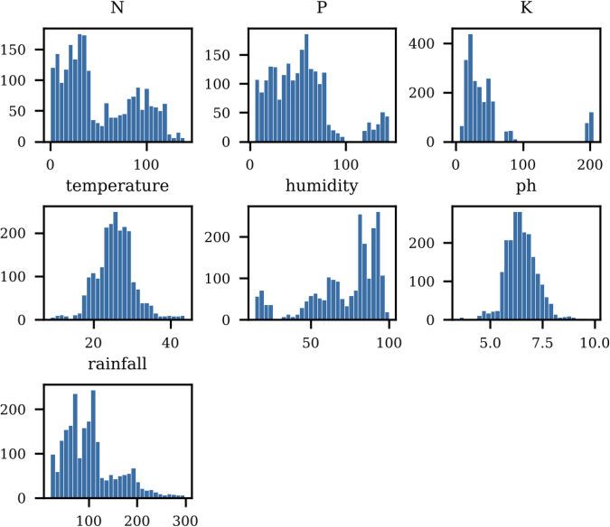
Fig. 1. Histograms of the seven input features.
We can identify any statistical outliers by using the 1.5IQR rule. There are outliers present in K (200), P (138), Annual Rainfall (100), Temperature (86), Ph (57), and Humidity (30). However, when looking at individual crops we can see these are actually valid agriculture requirements (See Figure 2). All of the 200 outliers in Potassium are from Apple and Grapes. 68 of the Annual Rainfall Outliers are Rice. As there are no data points outside of the thresholds within crop groups, we kept all samples.
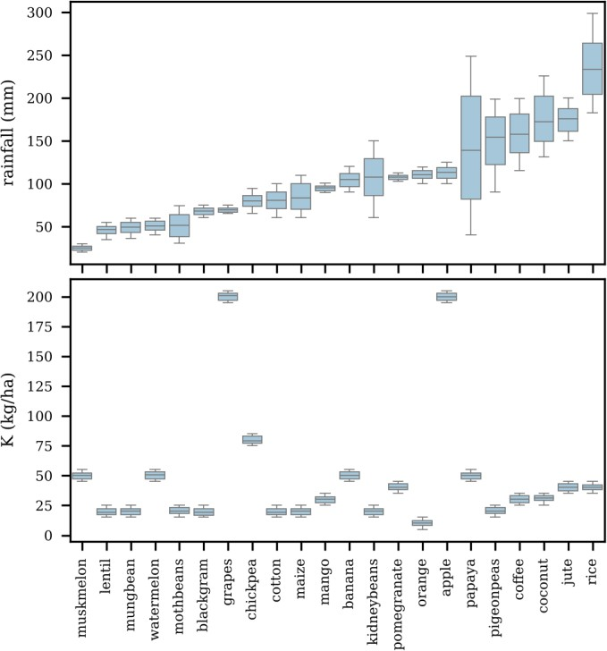
Annual Rainfall and Potassium per crop (sorted by Median Annual Rainfall). Apple and Grapes have a much higher Potassium. Rice has the highest Annual Rainfall.
There is a high correlation between Phosphorous and Potassium (r=0.74). All other features have a correlation below
0.25 (See Figure 3). All 7 features were kept.
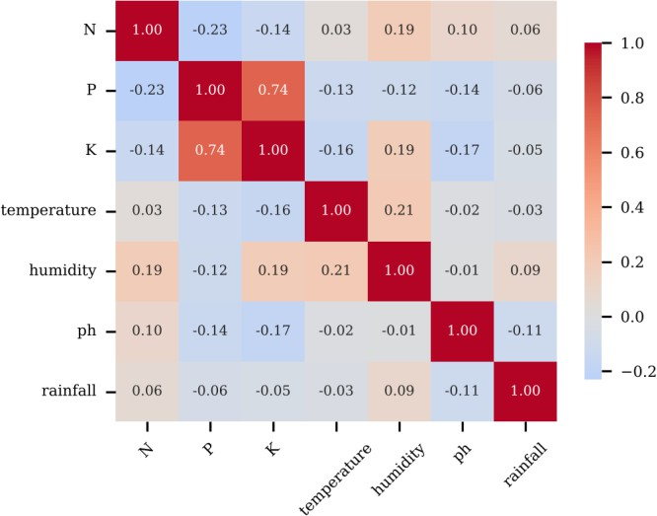
Fig. 3. Pearson correlation matrix of the input features.
- Preprocessing
We used NumPy [8] and scikit-learn [9] to perform a stratified split of the data in an 80/20 ratio (1760 train samples, 440 test samples). We performed standard scaling to ensure the data had a mean of 0 and a standard deviation of 1. We used StandardAero to apply this transformation strictly to training folds during cross-validation. We used Matplotlib [10] for visualization. We optimized the data types to reduce memory usage (See Appendix A).
- Classification Models and Configuration
We tested 7 different models. These included a linear model (Multinomial Logistic Regression with L2 regularisation and max iterations=2000), Decision Tree (unpruned, Gini Criterion), Random Forest (300 trees), KNN (K=5), SVM (RBF Kernel), Gaussian Naive Bayes and Gradient Boosting (100 estimators). We scored each model using accuracy and macro-F1. We also performed stratified 5-fold cross-validation on the training set.

Decision Tree, Random Forest and SVM were hyperparameter tuned using grid search. The best hyperparameters were Random Forest (100 trees, max depth=10, leaf node size=1, sqrt), SVM (C=100, Gamma=0.05), Decision Tree (Unlimited depth, leaf node size=2). We created an ensemble model using soft voting by averaging the predicted class probabilities for the tuned Random Forest, SVM, Gradient Boosting and Gaussian Naive Bayes models.
- Classification Performance and Overfitting Checks
TABLE II
Classification Results (Accuracy %, 440 Test Samples)

Model Train 5-fold CV Test Macro-F1
Logistic Regression | 97.39 | 96.82 ± 0.66 | 97.27 | 97.25
Decision Tree | 100.00 | 98.52 ± 0.68 | 97.95 | 97.94
Random Forest | 100.00 | 99.32 ± 0.53 | 99.55 | 99.55
KNN | 98.47 | 96.53 ± 1.21 | 97.95 | 97.93
SVM (RBF) | 98.58 | 97.90 ± 1.03 | 98.41 | 98.40

Gaussian NB | 99.49 | 99.49 ± 0.42 | 99.55 | 99.54
Gradient Boosting | 100.00 | 98.69 ± 0.34 | 98.86 | 98.87
Tuned Decision Tree | — | 98.58 | 97.95 | —
Tuned SVM | — | 98.41 | 99.09 | —
Tuned Random Forest | — | 99.43 | 99.55 | —
Soft-voting ensemble | 99.83 | 99.49 ± 0.55 | 99.55 | 99.55

All models achieved over 96% accuracy (See Table II). The Logistic Regression achieved an accuracy of 97.27% on the test set with almost identical accuracy on the training set (97.39%). This indicates the model isn't overfit but is limited by linear boundaries. The Decision Tree model memorized the training set (100%) and achieved 98.52% on the cross-validation. The Random Forest, Gradient Boosting, and Gaussian Naive Bayes models all achieved ~99.5% on the test set, indicating that the dataset is highly separable.
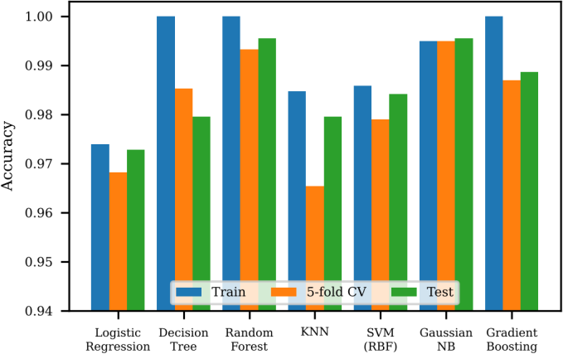
Fig. 4. Train, cross-validation, and test accuracy of the seven baseline classifiers.
The Ensemble achieved an accuracy of 99.55% on the test set (438/440 correct). It achieved a macro-F1 score of 0.995 and 99.49% +/- 0.55% on cross-validation. The learning curve (See Figure 5) shows the accuracy plateaus at ~99.2% with 700 samples in the training set. The accuracy has a 95% confidence interval of 98.4%-99.9%.
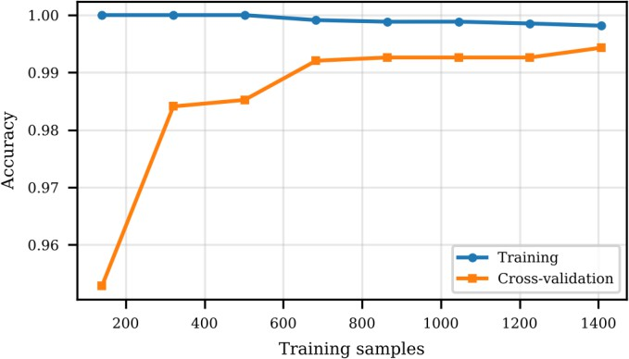
Fig. 5. Learning curve of the tuned random forest (5 -fold CV).
The ensemble model only made 2 errors on the test set (See Figure 6). One sample of Lentils was predicted as Moth beans and one sample of Rice as Jute. This is due to the logical similarity between low water legumes and high moisture crops. The Top 3 accuracy was 100% for all 440 samples.

Fig. 6. Confusion matrix of the soft-voting ensemble on the test set (zeros are left blank).
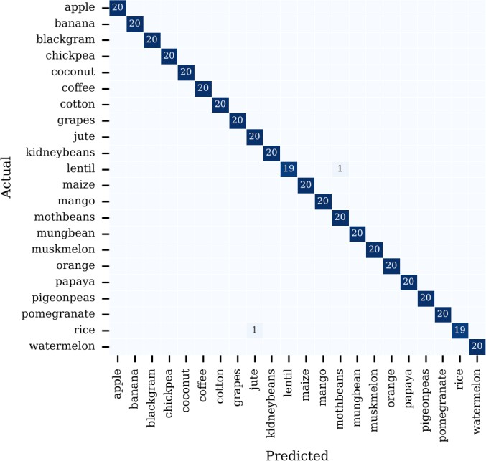
- Feature Importance
We looked at feature importance using Random Forest (Gini Importance) and Permutation Importance (20 repeats) on the test set. The top global features are Relative Humidity (0.375), Annual Rainfall (0.318) and Potassium (0.199) (See Figure 7). Temperature (0.013) and Ph (0.005) have less global influence. Using Univariate ANOVA F-Tests we can see Potassium has the highest F-statistic (F=27,238) due to Apple and Grapes being isolated. Humidity has the second highest F-statistic (F=3,104).
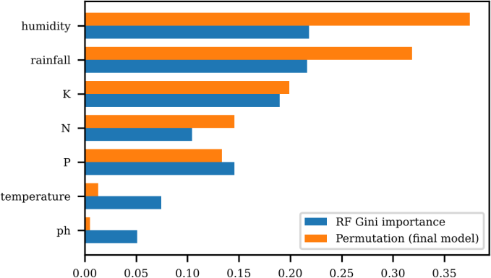
Fig. 7. Global feature importance: random forest Gini importance and permutation importance of the final ensemble.
Crop-specific z-score profiles and one - vs-rest models (Fig. 8) show that featur e roles shift per crop. Rainfall domin ates predictions for rice (z = +2.41, importanc e 0.53) and muskmelon (0.54), whereas nitr oge n dominates cotton (z = +1.82, importance 0.50), maize, and banana. Low humidity isolates chickpea and kidney beans (z = −2.45 and
−2.24), potassium isolates apple and grapes (z

= +3.0), and temperature isolates papaya (z =
+1.6).
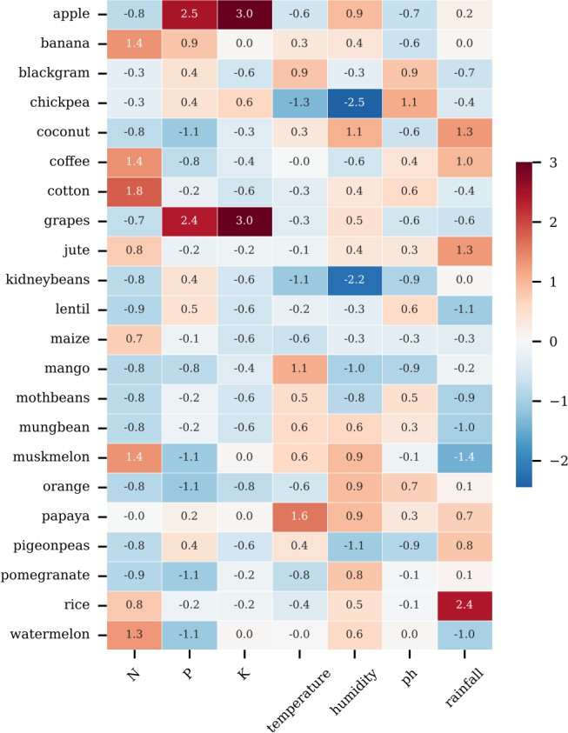
Fig. 8. Crop signatures: standardized difference between each crop's mean feature value and the overall mean (z-score).
- Clustering of Soil and Weather Profiles
We performed K Means [12] on the standardised features. We tried different amounts of clusters between 2 and 15 (See Figure 9). The Silhouette Score plateaus at ~0.34 -0.35 at 10+ clusters, so we decided to use 10 clusters. We looked at the performance of the model using ARI [15], NMI [16] and purity.
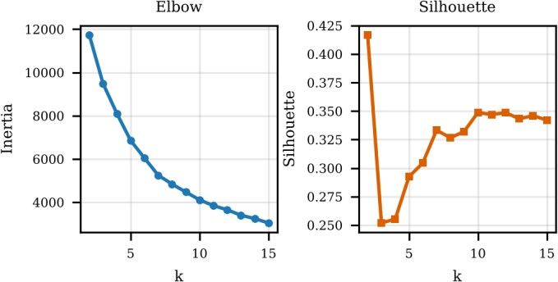
Fig. 9. Elbow (inertia) and silhouette scores of K-Means for K = 2–15.
K Means achieved a Silhouette Score of 0.349, ARI of 0.441,
Rice/Jute/Coffee, Cluster 1 contains Banana/Cotton/Maize and Cluster 4 contains Pulses.
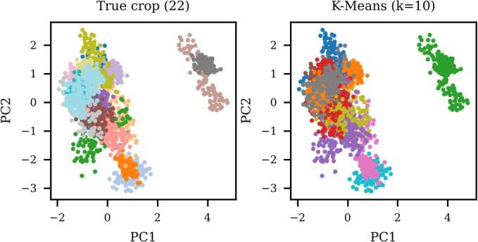
Fig. 10. PCA projection of the standardized data, colored by true crop (left) and by K-Means cluster (right).
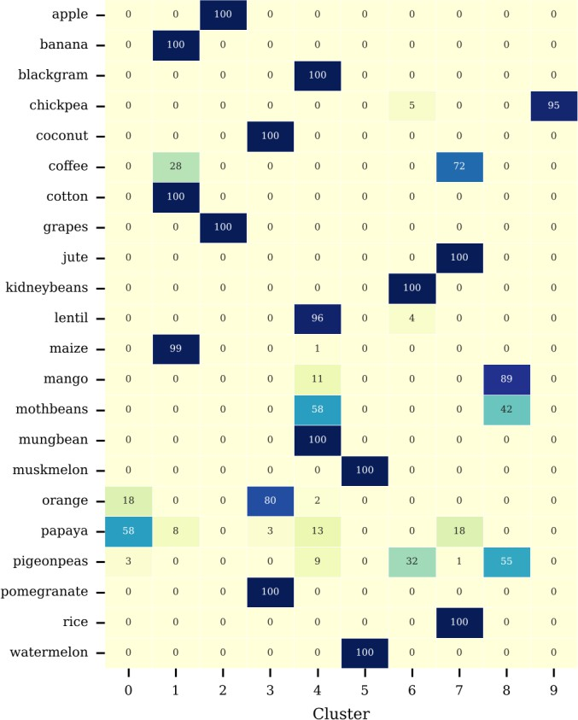
Fig. 11. Number of samples of each crop in each K-Means cluster (k = 10).
When increasing the number of clusters to 22 (Same number of crops) K Means achieved an ARI of 0.672, Ward Hierarchical achieved an ARI of 0.699 and the Gaussian Mixture Model (GMM) [14] achieved an ARI of 0.885 (NMI=0.965, Purity=0.906) (See Table III). GMM
outperformed the distance-based models as it can model non-spherical elongated distributions of crops.

and NMI of 0.748 with 10 clusters. Using PCA, we can see that C
TABLE III

46.1% of variance is captured by the 2 components (See Figure 10). The clusters (See Figure 11) can be seen to form clear clusters based on agriculture. Cluster 2 contains Apple and Grapes, Cluster 5 contains Muskmelon/Watermelon, Cluster 9 contains Chickpea (95/100), Cluster 7 conta ins
lustering Quality Against True Crop Labels

Method ARI NMI Purity Silhouette

K-Means, k = 10 | 0.441 | 0.748 | 0.428 | 0.349
K-Means, k = 22 | 0.672 | 0.839 | 0.771 | 0.347
Ward, k = 22 | 0.699 | 0.867 | 0.788 | 0.335
Gaussian mixture, k = 22 0.885 0.965 0.906 0.290

SUMMARY OF MAIN INSIGHTS
  - The crops are highly separable. Even the linear model achieved over 97% accuracy on the test set. The ensemble achieved a high accuracy of 99.55% (98.4%-99.9% confidence interval). This is much higher than our 80% target. The data is very clean (balanced classes, no missing values, no duplicated data, no outliers within crop) meaning these results are an upper limit compared to real world farm data.

  - Global decisions are influenced by moisture and Potassium. Humidity, Annual Rainfall, and Potassium are the most informative features globally. However, Nitrogen is a key factor for certain crops. Global feature importance doesn't show this.

  - A short list of recommendations is safer. We achieved 100% accuracy on the Top 3 recommendations. This shows having 3 recommendations will allow the farmer to use local knowledge (i.e. Seed availability, Market demand, Local traditions) to choose the best crop.

  - The high accuracy of the benchmark is sensitive to noise. From Table IV, we can see adding Gaussian noise to the features only reduces the ensemble accuracy by 1% when using 10% of the standard deviation. However, when increasing to 20% of the standard deviation, the accuracy drops significantly to 90.7%. When the noise is increased to 50%, the accuracy drops even further to 61.1%. When the noise is 20% and above, the simple logistic regression model is more robust. Real world IoT sensors and weather forecasts will have noise, so the model must be trained with noise in mind.
TABLE IV
Test Accuracy (%) Under Gaussian Feature Noise
Noise (× feature std) | Ensemble | Logistic regression
0.0 | 99.5 | 97.3
0.1 | 98.4 | 96.8
0.2 | 90.7 | 93.2
0.3 | 81.6 | 86.1

6) Impact on Sustainability and Ethical Considerations. Matching crops to soil and weather conditions will help reduce unnecessary use of fertilizers and water (SDG 2 and SDG 12). The cost to infer is minimal (Ensemble trained in under 6 seconds using 1 CPU core). However, as there is no data on yield or fertilizer, we cannot quantify exactly how much resources can be saved. The data represents regional conditions and does not take into account important factors such as soil texture, pests, market prices, and long-term weather trends. Recommendation tools should be used to assist rather than replace local agricultural advisors.

CONCLUSION
We analysed a crop recommendation framework using 2200 samples of 22 different crops. The ensemble achieved an accuracy of 99.55% on the test set and 100% on the Top 3. Humidity, Annual Rainfall and Potassium are the main global factors. Nitrogen is a dominant factor for certain crops. The GMM clustering matched closely to the crop profiles (0.885 ARI). Sensitivity analysis shows that the accuracy will be reduced in the real world due to noise in the field. Future work should be done to train the model with noise in mind.

Future work includes validating the models with real field data from a variety of geographical locations, including yield and fertiliser information to quantify the true resource saving, training with noise to increase fault tolerance against sensor noise, adding more variables such as soil texture, seasonal forecasting and market trends, and creating an intuitive web/mobile interface for farm advisors.

APPENDIX A: MEMORY EFFICIENCY
The original dataset has features stored as 64bit. We reduced the memory usage by storing soil nutrients (N/P/K) as 8bit unsigned integers. Continuous weather features were converted to 32bit floats. Repeated string values for crops were stored categorically. This can be seen below:

int_cols = ["N", "P", "K"]
float_cols = ["temperature", "humidity", "ph", "rainfall"] df[int_cols] = df[int_cols].astype("uint8") df[float_cols] = df[float_cols].astype("float32") df["label"] = df["label"].astype("category")
kb = df.memory_usage(deep=True). sum () / 1024

TABLE V
Memory Usage Before and After Type Reduction (KB)

0.5 61.1 68.2
Column Original type
New type Before After

  - The unsupervised clustering provides useful insight but is not fully aligned to crops. K Means identified meaningful clusters of similar crops (Apple/Grapes, Muskmelon/Watermelon, Pulses). However, it could not separate crops within clusters. The Gaussian Mixture with 22 components identified the crops much better (0.885 ARI).
N int64 uint8 17.2 2.1
P int64 uint8 17.2 2.1
K int64 uint8 17.2 2.1
temperature float64 float32 17.2 8.6
humidity float64 float32 17.2 8.6
ph float64 float32 17.2 8.6
rainfall float64 float32 17.2 8.6
label object/str category 120.6 3.4
Total 241.0 44.8

Re-encoding string labels to category types and casting numeric features reduced total data frame memory from 241.0 KB to

44.8 KB (81.4% reduction, Table V) without any change in model accuracy.

USE OF AI STATEMENT
All numbers in the report have been generated by running the code on the dataset. We have reviewed the results and confirmed they match the output of the code. We take responsibility for the content of this report.] No AI was used to generate or alter data.

PLAGIARISM RATIO
similarity ratio 4% and AI-detection ratio 40%, from the plagiarism-checking tool used (plagiarismdetector).

REFERENCES
- United Nations, "The 17 Goals", Sustainable Development Goals, Dept. of Economic and Social Affairs. Online. Available: https://sdgs.un.org/goals

- A. Ingle, "Crop Recommendation Dataset", Kaggle. Online. Available: https://www.kaggle.com/datasets/atharvaingle/crop-recommendation-dataset

- K.G. Liakos, P. Busato, D. Moshou, S. Pearson and D. Bochtis, "Machine Learning in Agriculture: A Review", Sensors, vol. 18, no. 8, 2018, pp. 2674.

- T. van Klompenburg, A. Kassahun and C. Catal, "Crop yield prediction using machine learning: A systematic literature review", Comput. Electron. Agric., vol. 177, 2020, pp. 105709.

- S. Pudumalar, E. Ramanujam, R.H. Rajashree, C. Kavya, T. Kiruthika and
J. Nisha, "Crop recommendation system for precision agriculture", in Proc. 8th Int. Conf. Advanced Computing (ICoAC), Chennai, India, 2016,
pp. 32-36.

- L. Breiman, "Random Forests,", Mach. Learn., vol. 45, no. 1, 2001, pp. 5-
32.

- W. McKinney, "Data structures for statistical computing in Python," Proc. 9th Python in Sci. Conf., 2010, pp. 56 -61.

- C.R. Harris et al., "Array programming with NumPy", Nature, vol. 585, 2020, pp. 357-362.

- F. Pedregosa et al., "Scikit-learn: Machine learning in Python", J. Mach. Learn. Res., vol. 12, 2011, pp. 2825 -2830.

- J.D. Hunter, "Matplotlib: A 2D graphics environment", Comput. Sci. Eng., vol. 9, no. 3, 2007, pp. 90-95.

- R. Kohavi, "A Study of Cross-validation and Bootstrap for Accuracy Estimation and Model Selection", Proc. 14th Int. Joint Conf. Artif. Intell. (IJCAI), 1995, pp. 1137-1143.

- J. MacQueen, "Some Methods for Classification and Analysis of Multivariate Observations", Proc. 5th Berkeley Symp. Math. Stat. Probab., vol. 1, 1967, pp. 281 -297.

- P.J. Rousseeuw, "Silhouettes: A graphical aid to the interpretation and validation of cluster analysis", J. Comput. Appl. Math., vol. 20, 1987, pp. 53-65.
- A.P. Dempster, N.M. Laird and D.B. Rubin, "Maximum likelihood from incomplete data via the EM algorithm", J. R. Stat. Soc. B., vol. 39, no. 1, 1977, pp. 1-38.

- L. Hubert and P. Arabie, "Comparing partitions,", J. Classif., vol. 2, no. 1, 1985, pp. 193-218.

- A. Strehl and J. Ghosh, "Cluster ensembles —A knowledge reuse framework for combining multiple partitions", J. Mach. Learn. Res., vol. 3, 2002, pp. 583-617.

